# Python Setup

* Python is already setup on the computers in the lab room.
* You are not required to setup Python on your home computer, but you may find it helpful to be able to work on your labs at home.
* If you would like to setup Python on your home computer, follow the instructions below.

## Download Python

* You can download Python here: <https://www.python.org>
* Under Downloads pick Python 3….

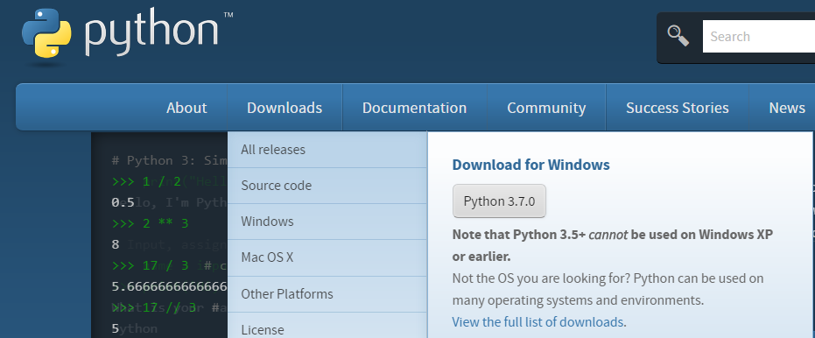

## Install Python

Run the file you just downloaded to install Python.

## Open the Editor

Locate and open the program IDLE on your computer

## Test with a Simple Program

* In IDLE type: print(“hello world!”)
* Followed by the enter key
* You should see the following:

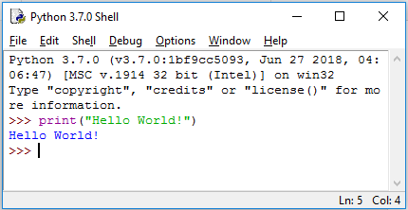

* As long as the program displayed Hello World! Back to you, you are ready to go ☺